|  |  |  |  |  |  |
| --- | --- | --- | --- | --- | --- |
| Date | 24-Nov-22 | | | Tester Name | Mohammad Yusuf |
| Environment | Select Environment | | | Login used |  |
| Operating System | Select OS | Version: | Update: | | |
| Software Used | Select Software | Version: | Update: | | |
| Select Software | Version: | Update: | | |
| Release version |  | | | | |
| Title | M33.05 Stop additional tax | | | | |
| Test Type | Regression | | | | |
| Test Scenario | Stop additional tax | | | | |
|  |  | | | | |
| Expected Results |  | | | | |
| Pass/Fail | Select | | | JIRA# | N/A |

Describe your steps with screenshots:

Person profile

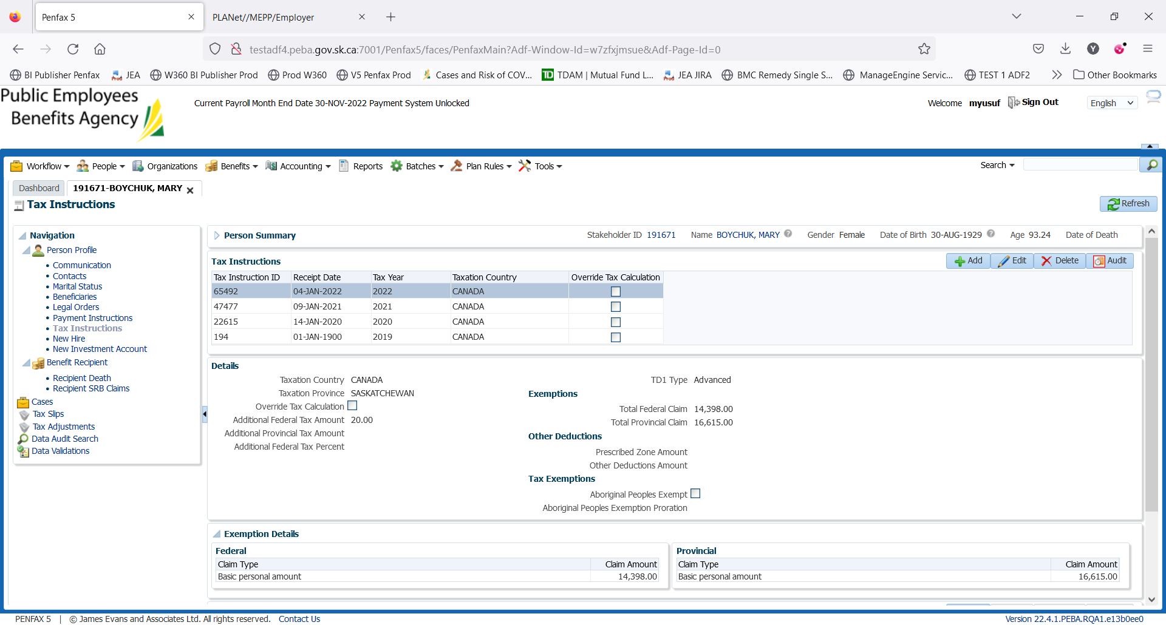

BR

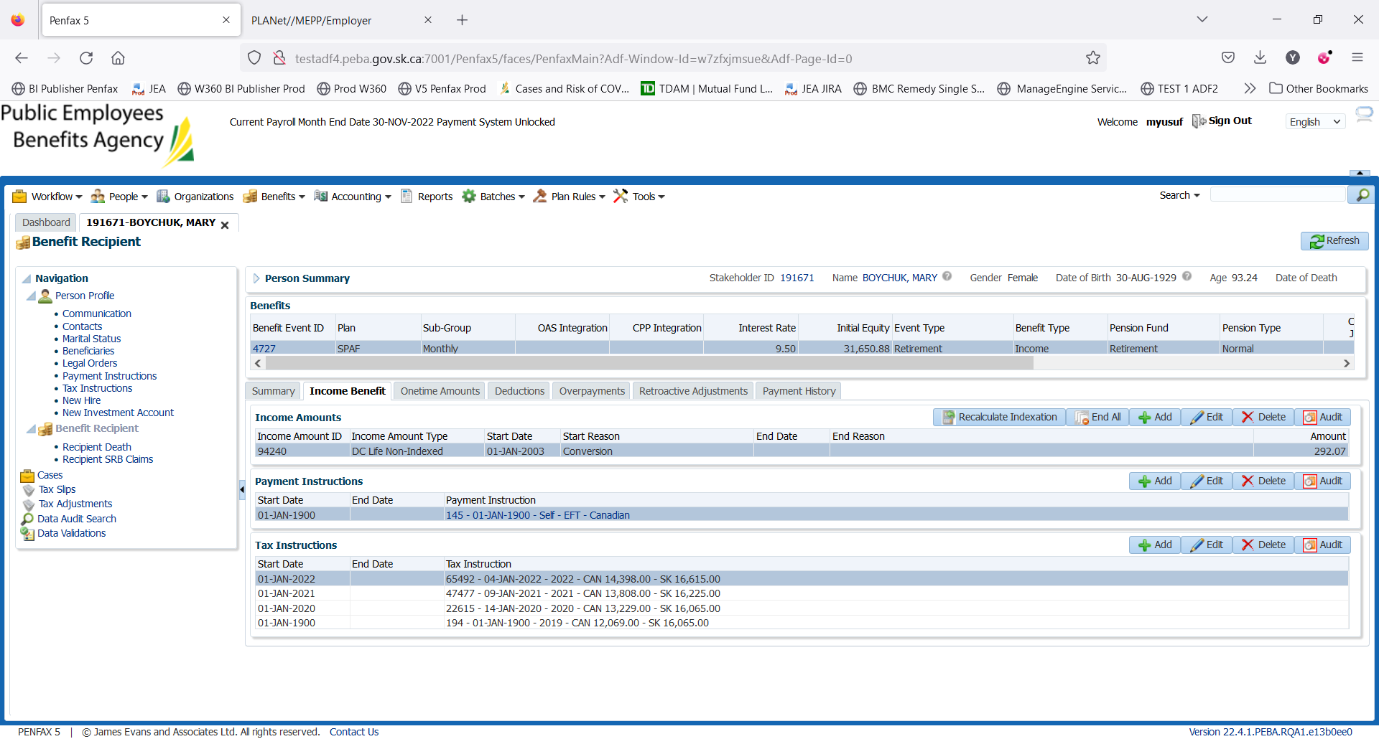

Adding the New Tax Instructions without additional Tax amount

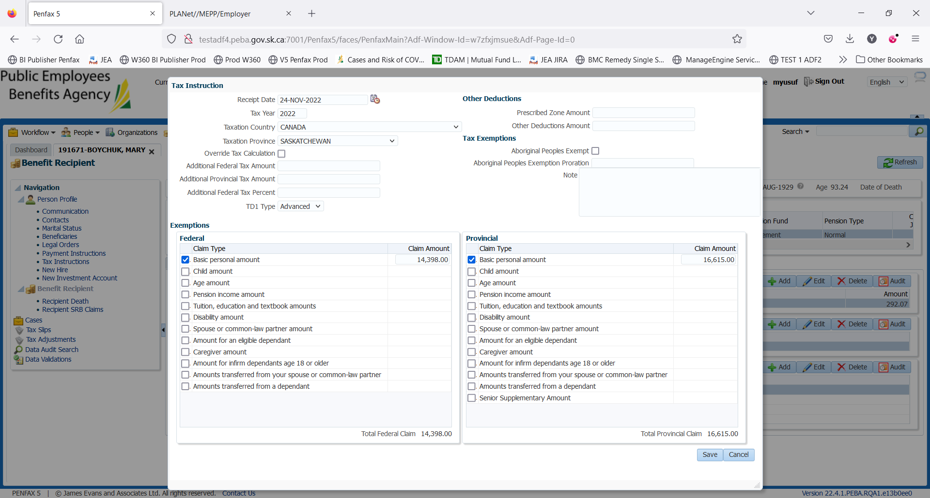

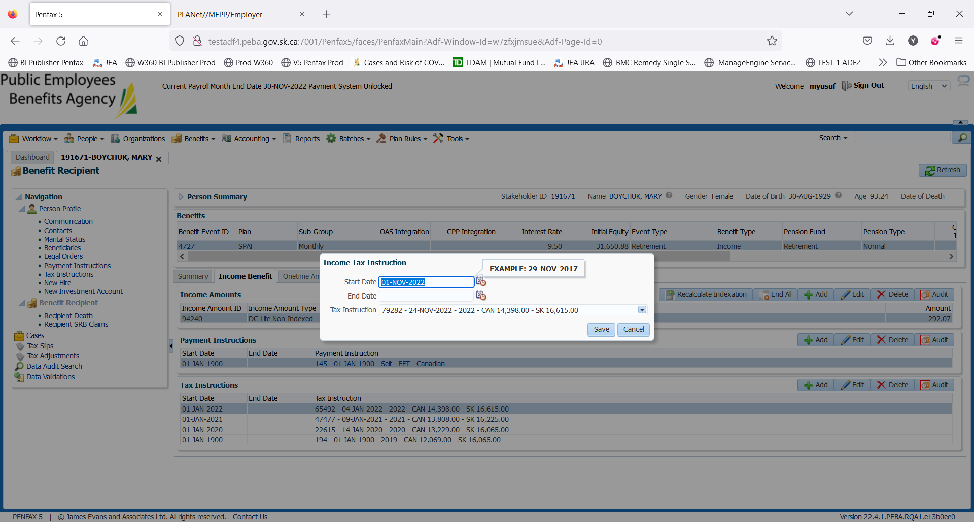

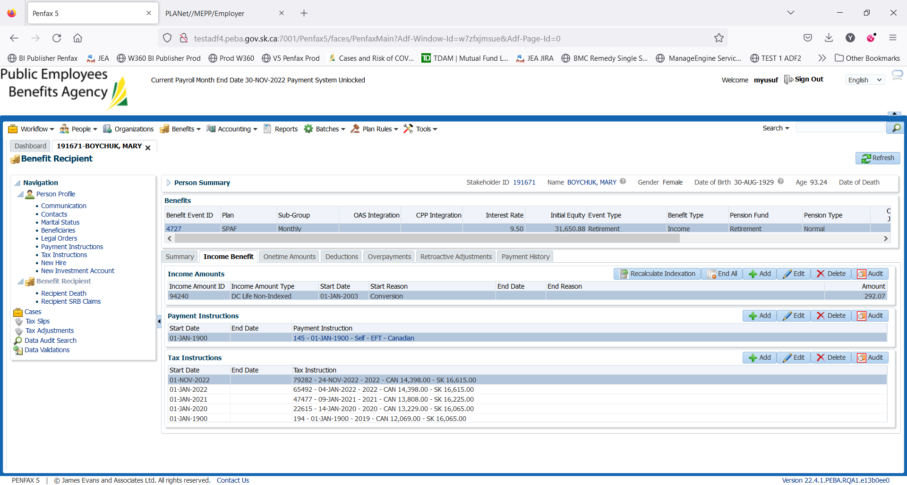

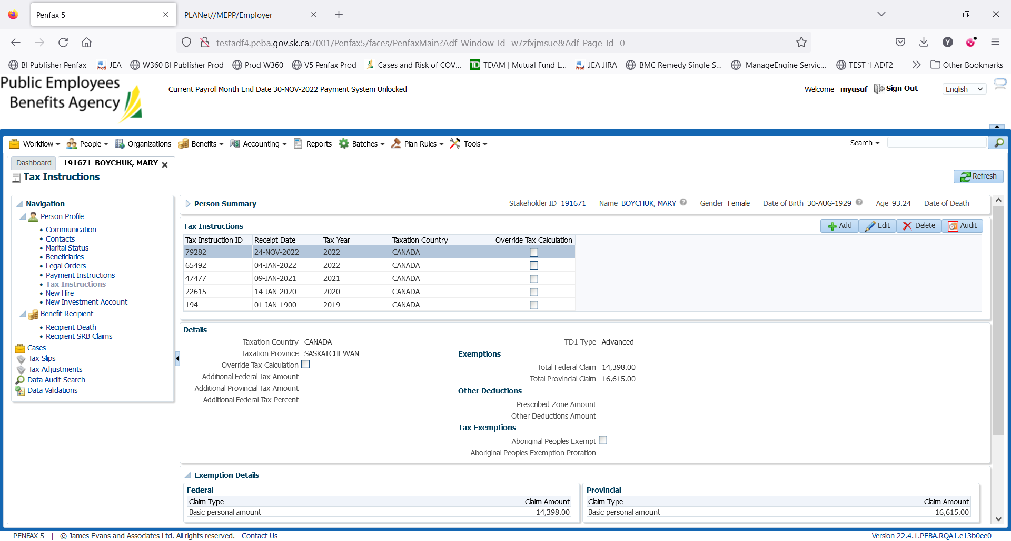

Remove additional tax from 04 jan 2022 TI

Two methods to remove additional Tax: Add a new Tax instruction or edit the prior Tax instructions.

Verify next payment – Nov 2022

An additional tax $20 should not be deducted. Can be verified after the payment batch is run